**Sprint 2 Plan**

Summarize Everything

Summarize Everything

End: Feb. 8, 2022

Revision: 1

Revision Date: Jan. 21, 2022

**Goal:**

Create an initial prototype of the model and have functional website components deployed.

**Task listing (Organized by user story):**

*User story 1:* As a user, I would like to be able to access the website in my web browser and be able to get a summary for simple .txt files.

*Task 1:* Set up a development environment to create a website. (1 hour)

*Task 2:* Add a button which allows the user to upload a file to the server. (1 hour)

*Task 3:* Have the frontend pass the input to the backend to be summarized using the model. (1 hour)

*Task 4:* Have the backend pass the result back to the frontend. (0.5 hours)

*Total for user story 1:* ***5 points***

*User story 2:* As a developer, I would like to have a model that performs accurately for most summarization tasks taken from the test set.

*Task 1:* Set up API instance for multi-model inference and comparison. (0.5 hours)

*Task 2:* Implement a metric and live viewing service which assesses the performance of a model. (1 hour)

*Task 3:* Create a way to compare multiple models across various inputs. (1 hour)

*Total for user story 2:* ***8 points***

*User story 3:* As a developer, I would like to be able to visualize/gain statistical insights into my datasets to choose the most viable ones.

*Task 1:* Use a metric to gather data about different datasets. (1 hour)

*Task 2:* Display the data using some form of graph which allows for comparisons between datasets. (1 hour)

Task 3: Set up tensorboard to compare model performance on each dataset and dataset mix. (1.5 hours)

*Total for user story 3:* ***6 points***

*User story 4*: As a developer I would like to avoid binary/non-text files from being submitted

*Task 1*: Add checks to avoid binary files (0.5 hours)

*Total for user story 4:*  ***3 points***

*User story 5:* As a user, I would like to view the summarized content in a simple and easy to read format.

*Task 1*: View a small character counter in the text box (0.5 hours)

Task 2: View alerts when text has been summarized or there is an error

(0.5 hours)

Task 3: View summarized content retrieved from model (0.5 hours)

*Total for user story 5*: ***3 points***

**Team Roles:**

Jess Fan: Project Owner, Developer

Pushu Zhang: Developer

Janet Zhu: Developer

Sebastian Medina: Scrum Master, Developer

Victor Ho: Developer

**Initial task assignment:**

Jess Fan:

*User Story* - Stories 2 and 3

*Initial Task* - Task 1

Pushu Zhang:

*User Story* - Stories 3

*Initial Task* - Task 3

Janet Zhu:

*User Story* - Stories 3

*Initial Task* - Task 3  
Sebastian Medina:

*User Story* - Stories 1, 4, and 5

*Initial Task* - 1.1, 1.2, 4.1, 5.1, 5.2

Victor Ho:

*User Story* - Stories 1 and 5

*Initial Task* - 1.3, 1.4, 5.3

**Initial Burnup chart:**

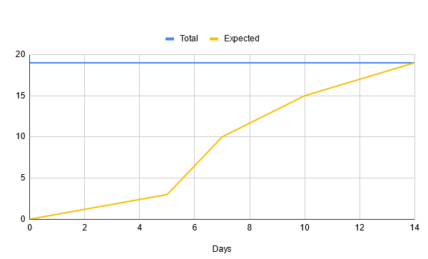

**Initial scrum board:**

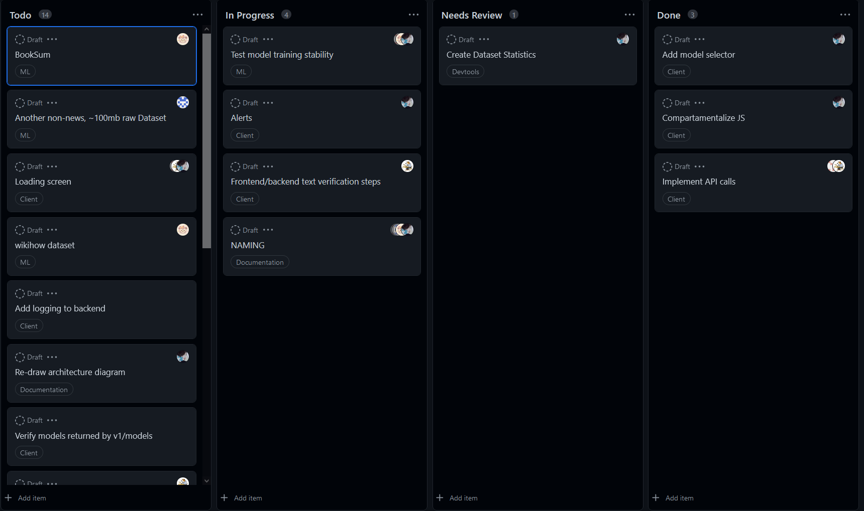

**Scrum times:**

* Monday: 8pm - 9pm
* Wednesday: 8pm - 9pm
* Friday: 3pm - 4:30pm [**TA meeting** 3pm - 4pm]